

PROJECT

DESKTOP PUBLISHING

Submitted by - Submitted to –

Name – gorang lamba Name – Jasleen Kaur

UID – 23BCA10245 Designation – Assistant Prof.

Section – 23BCA 2 – A

**Process**

**Step 1: Setting Up the Workspace**

1. Open Adobe Photoshop and create a new document with the desired dimensions (e.g., 1920x1080 pixels for HD resolution).
2. Import or paste the background image (a school hallway) into the document.

**Step 2: Adding the Character**

1. Find or create an illustration of a character with headphones, resembling the one in the uploaded image.
2. Import the character illustration into your Photoshop project as a new layer.
3. Position the character in the bottom-left corner.

**Step 3: Adding the Text Elements**

1. Use the **Text Tool (T)** to create text boxes.
2. In the first text box, write the narrative text about Sophia:
   * "There was a girl named Sophia who didn’t want to socialize much. In a room full of people, she'd be in the corner with her headphones on, completely lost in her music…."
3. In the second text box, add the inner thought:
   * "World is too noisy and chaotic… I only find peace, calm, and clarity in music."
   * Emphasize "I just love music" in red or another standout color.

**Step 4: Designing the Heartbeat and Headphones Graphic**

1. Use the **Pen Tool (P)** to draw the heartbeat line.
2. Create or import a headphone graphic and position it around a heart symbol.
3. Use **Layer Styles** (such as Stroke, Glow) to make the graphic pop.

**Step 5: Styling and Composition**

1. Adjust the opacity of background layers to focus attention on the character and text.
2. Add a subtle vignette or gradient to enhance the mood.
3. Use **Blending Modes** to integrate all elements cohesively.
4. Ensure the text is legible by tweaking font size, color, and contrast against the background.

**Step 6: Final Touches**

1. Add any additional effects or filters as needed to achieve the desired artistic feel.
2. Save the project in both PSD format (for future edits) and export as a high-quality JPEG or PNG.

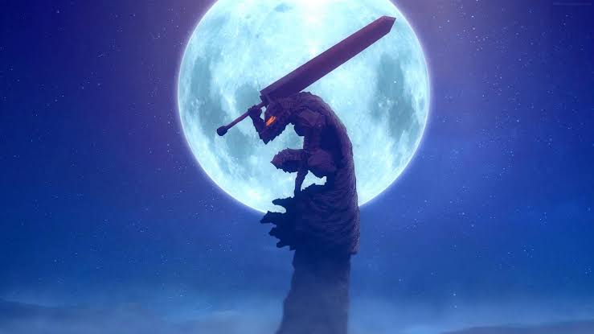

**Story:-**

The Black Swordsman and the Moon

The night was as still as death, the only sound the whisper of wind through the barren landscape. A lone figure stood atop a crumbling tower, his silhouette stark against the backdrop of a colossal, pale moon. This was Guts, the Black Swordsman, a man haunted by a past of unspeakable horrors and a future filled with unrelenting darkness.

His sword, the Dragonslayer, a monstrous weapon forged in the fires of a dying world, reflected the moonlight like a beacon of defiance. It was a symbol of his relentless pursuit of vengeance against the God Hand, a cabal of demonic beings who had twisted his life into a nightmare.

His armor, once shining and pristine, was now a macabre tapestry of scars and rust, a testament to the battles he had fought and the suffering he had endured. Yet, his eyes burned with a fierce determination, a flicker of hope amidst the despair.

As he gazed at the moon, a sense of loneliness washed over him. He was a warrior, a survivor, a legend, but he was also a man, a man who craved companionship and redemption. He knew that his path was a solitary one, a journey into the abyss of his own soul.

But tonight, under the watchful eye of the moon, he found solace in the silence. He was not alone. The moon, a silent witness to the universe's tragedies and triumphs, shared his burden. It understood the weight of his existence, the constant struggle against the darkness within and without.

With a deep breath, Guts turned away from the moon and back to the horizon, his gaze fixed on the path ahead. He knew that the road would be long and arduous, filled with trials and tribulations. But he also knew that he would not waver, that he would continue his quest for vengeance and redemption, no matter the cost.